**EXPRIMENT NO-11**

**CSA1142-OBJECT ORIENTED ANALYSIS AND DESIGN**

**CONFERENCE MANAGEMENT SYSTEM**

**USE CASE**

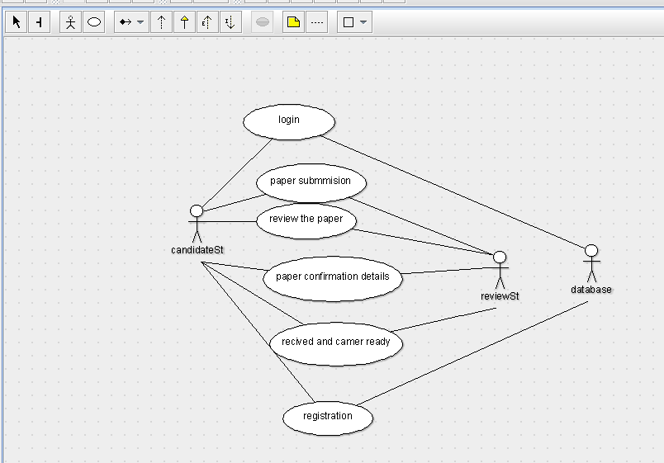

STATE DIAGRAM

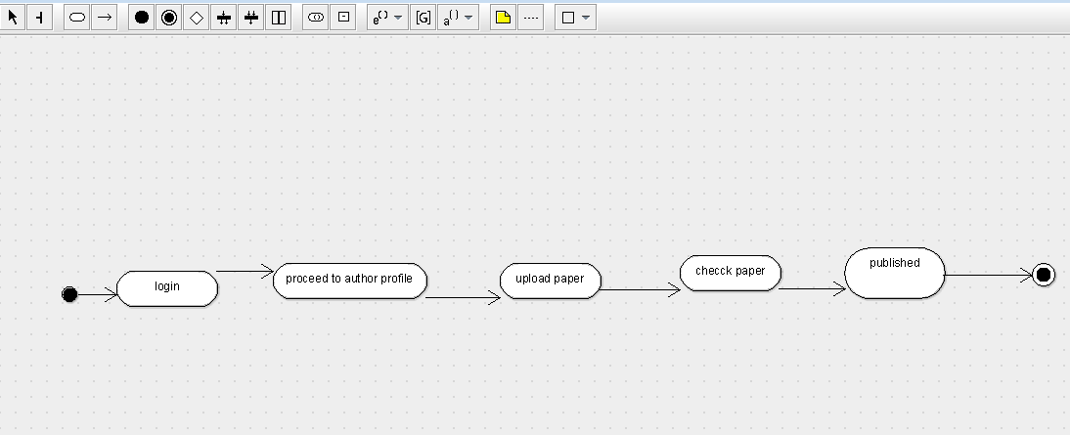

SEQUENCE DIAGRAM

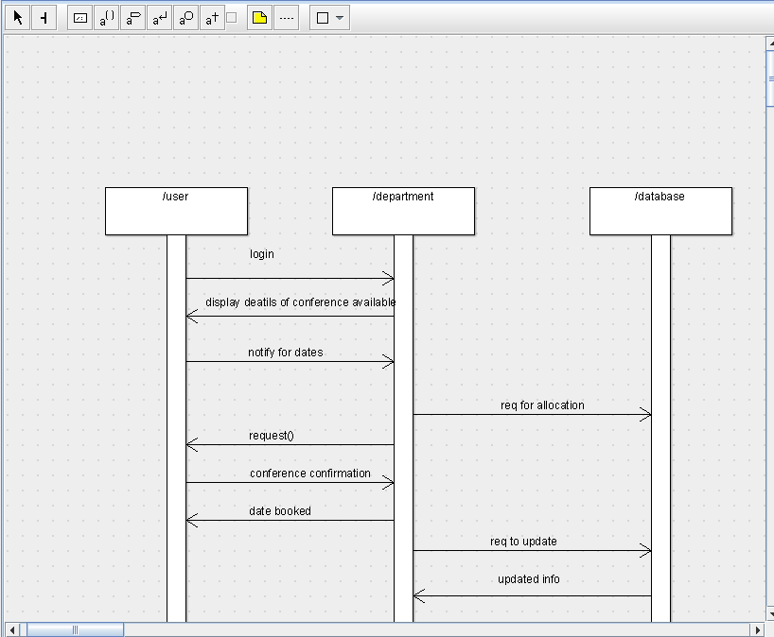

DEPLOYMENT DIAGRAM

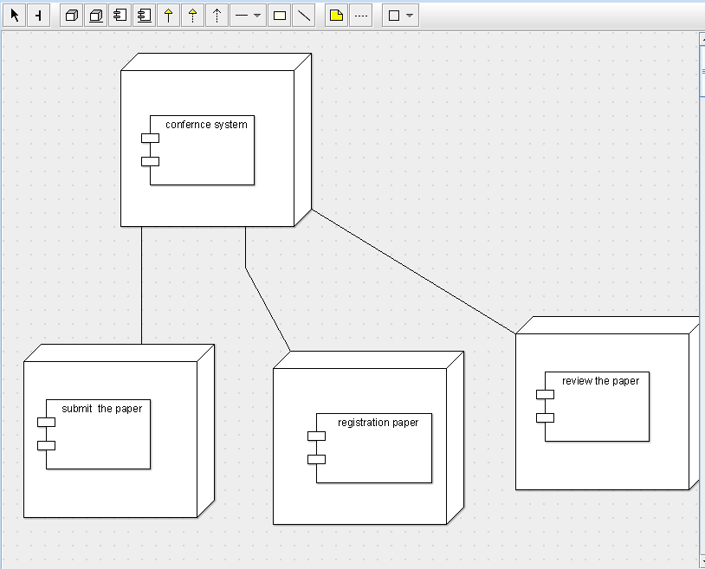

COMPONENT DIAGRAM

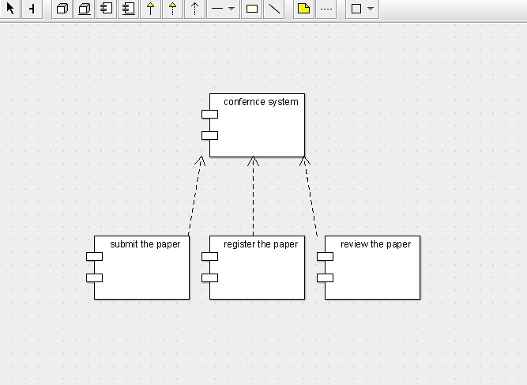

COLLABORATION DIAGRAM

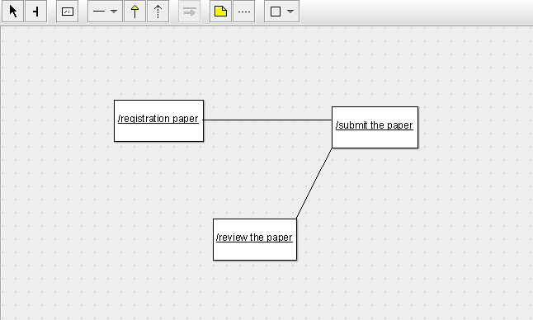

CLASS DIAGRAM

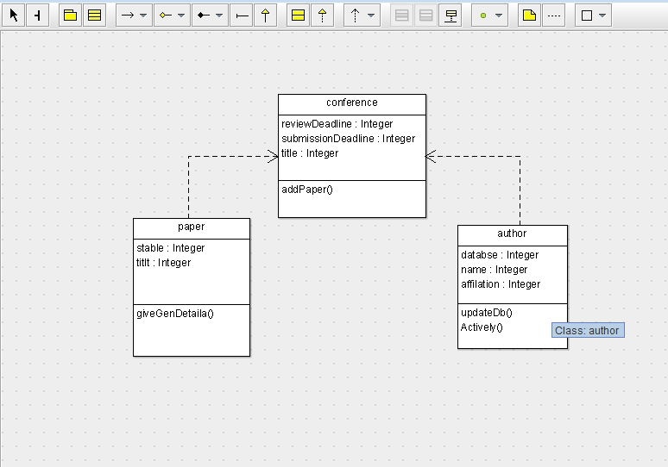

ACTIVITY DIAGRAM

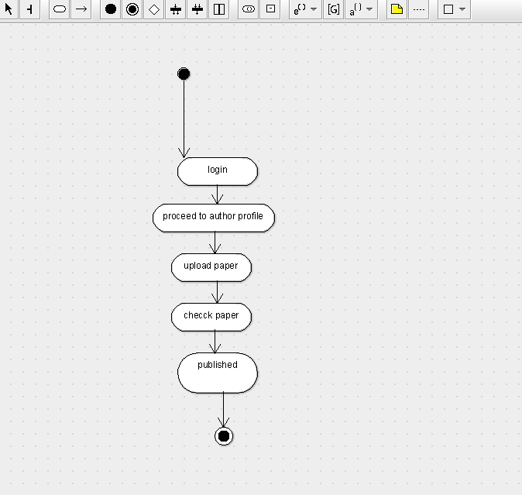

SKELETON CODE;

public class author {

  public Integer databse;

  public Integer name;

  public Integer affilation;

  public void updateDb() {

  }

  public void Actively() {

  }

}

public class conference {

  public Integer reviewDeadline;

  public Integer submissionDeadline;

  public Integer title;

  public void addPaper() {

  }

}

public class paper {

  public Integer stable;

  public Integer titlt;

  public void giveGenDetaila() {

  }

}